Emmanuel Nimo

Question 1

The clients are the ones that send out requests to the servers. And the servers response by searching the information from database and give feedback to client on what has been requested at the web browser. The diagram below represents the Dynamic Client-Server interactions that occurs when computer users make request on their web browser

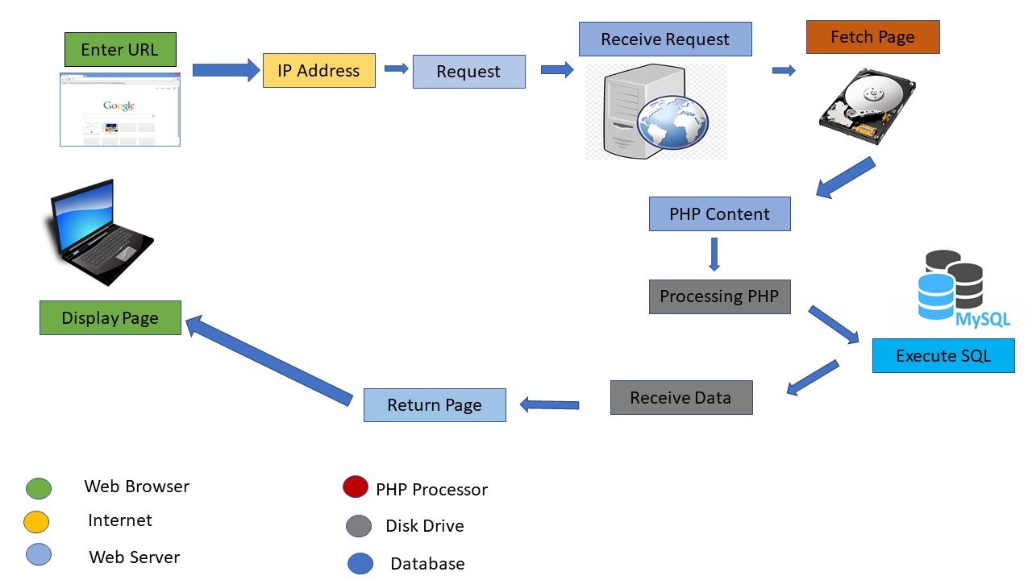

Question 2

Web concern refers to the various key elements or standards that are incorporated in web development. The concerns include: the content (information shared), presentation (appearance of the information) and behavior (responsive features).

Question 3.

|  |  |
| --- | --- |
| Concerns | Technologies |
| Content | HTML |
| Presentation | CSS |
| Behavior | JavaScript, PHP, pearl, |

Question 4.

|  |  |  |
| --- | --- | --- |
| HMTL 5 | XHTML | HTML 4 |
| * Combines the best features of XHTML AND HTML into one. * Simplified syntax. * Has additional functionalities such embedding of video without using plugin, geographic position, * There is extra support for HTML 5 in all web browsers. * HTML5 has adopted the popular web standard | * Syntax are tightened up. * All opened tags must be closed | * It has a loose syntax. * They are automatically ended when a new paragraph is started meaning, there is no need to close tag. |